**Shadows Midtones Highlights**

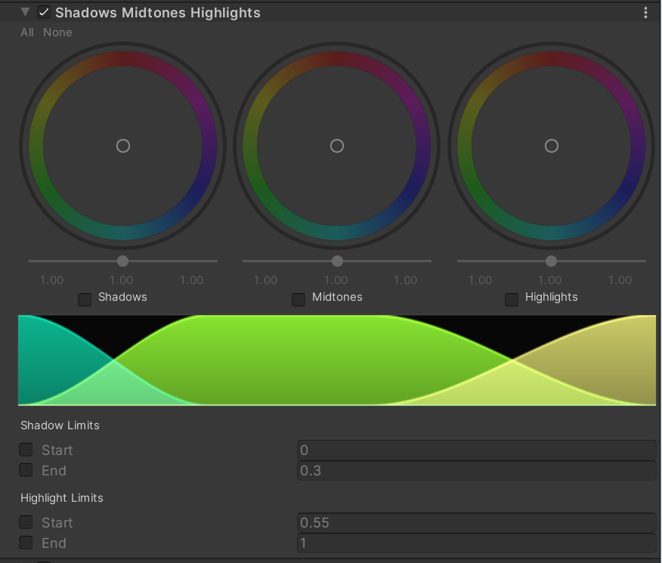

Why：

工作原理类似于色调分离，不同之处在于它还可以控制中间色调，可以分别控制阴影，中间色调和高光区域。

How：

luma = GetLuminance(colorLinear);

float shadowsFactor = 1.0 - smoothstep(_ShaHiLimits.x, _ShaHiLimits.y, luma);

float highlightsFactor = smoothstep(_ShaHiLimits.z, _ShaHiLimits.w, luma);

float midtonesFactor = 1.0 - shadowsFactor - highlightsFactor;

colorLinear = colorLinear * _Shadows.xyz * shadowsFactor

                        + colorLinear * _Midtones.xyz * midtonesFactor

                        + colorLinear * _Highlights.xyz * highlightsFactor;